Activities to teaching students SCISSORS Skills
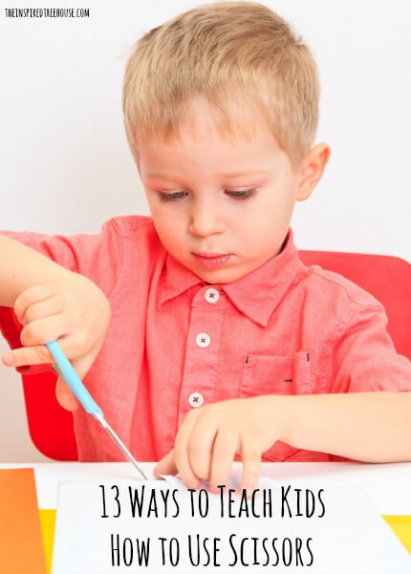
Kids are ready for their first exposure to cutting with scissors at 2 years old. Sound crazy? Let me clarify, unless your kid looks great with super short bangs or you were thinking your curtains needed a little trim, NEVER (ever ever ever) give a 2-year-old a pair of scissors and then walk away. Instead, have a seat for a few minutes every so often and try some of these cutting activities for kids! Your kiddo’s first attempts with new developmental milestones will just be exploration and exposure – let them try snipping paper their own way (even if they’re holding the scissors upside down).
People often wonder is using scissors is a milestone? Once your child has explored a little bit and is willing to tolerate hand over hand assistance, try the following:
Start Them Young! Early scissors skills
- Give multiple opportunities for picking scissors up and grasping them the right way by having the child put scissors down in between each cutting task.
- Place stickers on each of your child’s thumbs and then refer to them during cutting. Tell your child to practice “thumbs up cutting”, meaning that they can see both of the stickers on their thumbs while using scissors (on the hand that’s stabilizing the paper and on the hand that’s holding the scissors).
- Practice snipping with a purpose! Snip fringe on paper to make grass or a lion’s mane or set out long strips of paper (about 1” wide) and have kids snip off small pieces to make confetti.

Target Practice: Moving Scissors Forward on the Paper
- Place a sticker in the middle of a piece of paper and have the child cut across until he reaches it. Using a target helps kids develop smooth forward movement of scissors and impulse control to stop when they’ve reached the target point.
- Tear a gummy bear or fruit snack in half. Push the sticky part down on the paper (it should stick there by itself) and have the child cut toward it. When they reach the snack, they get to eat it!
- Place stickers in a line across the page and have the child cut the stickers in half as they move scissors forward.
- Encourage kids to move their stabilizing hand along the page as they cut (tell them their hand should move next to their scissors).

The Bottom Line: Developing Accuracy and Control
- Again, target practice helps here! This time, draw a line on the paper first and then place the stickers along the line for kids to cut in half. This gives exposure to the concept of cutting on a line, but provides mini targets along the way
- Next, place only one sticker or your fruit snack (see above) at the end of the line and have the child cut toward the target, keeping scissors on the line.
- Make the cutting lines as thick as they need to be for your child to be successful and gradually make them thinner as the child develops better accuracy.

Get in Shape! Learning to Cut Out Shapes
- Draw a dotted line from the edge of the paper to show your child where to cut into the paper to reach the shape.
- Draw an arrow on the paper indicating which direction the child should go when cutting around the shape. Right-handed kids will cut in a counterclockwise direction, left-handed kids will cut in a clockwise direction.
- Draw a dot or place a sticker at a point past the corner of the shape, showing the child that he has to cut further than the line in order to turn the corner without snipping it off.

http://theinspiredtreehouse.com/teach-kids-how-use-scissors/

